Instruction for use HeartSave myPAD Trainer
HeartSave myPAD Trainer
English 24800 EN
24800 EN Revision:
Revision:A
Release Date:07/2025
Masthead
Publisher
Manufacturer Primedic (Jiangsu) Medical Technology Co.,Ltd.
Address No.1 Baisheng Road, Development Zone, Danyang, Jiangsu, China

Tel. 86-511-86900833
Fax 86-511-86900851
Postal code 212300
Web www.primedic.com


Metrax GmbH
Address:Rheinwaldstr.22, 78628 Rottweil, GERMANY
info@primedic.com
+49 (0) 741 2570

Proprietary note
The manufacturer reserves all rights to these operating instructions.Without approval from the manufacturer, these operating instructions may not be duplicated or made accessible to third parties.The same applies to individual parts or excerpts of these operating instructions.
Non-compliance with this gives rise to a right to claim damages and can have consequences under criminal law (refer to ISO 16016).

Document 24800
Revision A
Date of issue 07/2025

These instructions for use may be changed by the manufacturer without further notice.

Contents

1Introduction HeartSave myPAD Trainer5
1.1Foreword5
1.2Validity5
1.3Intended use5
1.4Disclaimers5
1.5Safety notice5
2Device description5
2.1Description of device details5
2.2Language button10
2.3Child button10
3Preparation before starting device10
3.1Unpack10
3.2Prepare battery10
3.2.1Battery installation10
3.2.2Battery removal10
4Using HeartSave myPAD trainer11
4.1Switch on the trainer11
4.2Connect electrode cables with pads11
4.3Inserting electrodes11
4.4Apply auxiliary pads (optional)11
4.4.1Steps for applying the auxiliary pads12
4.4.2Function of auxiliary pads12
4.5Apply electrodes12
4.6Analysing rhythm13
4.6.1Start the analysis13
4.6.2Interrupt the analysis13
4.7Simulate defibrillation13
4.7.1Shock advised – Simulation: Shock recommended14
4.7.2No shock advised – Simulation: No shock recommendation14
4.8CPR – Cardiopulmonary Resuscitation14
4.8.1CPR with respiration14
4.8.2CPR without respiration14
4.8.3CPR feedback sensor (optional)15
4.9Switch off the Trainer15
5Product repair and maintenance16
5.1Device Maintenance16
5.2Electrode pads maintenance16
5.3Battery maintenance16
5.4Programming the trainer17
6Disposal17
7Technical specification17
8Warranty18
Appendix A: Index Diagram20
Appendix B: Pictograms20

Introduction HeartSave myPAD Trainer

Foreword
Dear User,
Thank you for selecting HeartSave myPAD Trainer.The HeartSave myPAD Trainer you have acquired is not a defibrillator but only used for training purposes and must not be used on patients.
Realistic training scenarios are provided to simulate the use of HeartSave myPAD defibrillator in a real emergency case.
A HeartSave myPAD Trainer is clearly identified by "TRAINING ONLY" printed on the surfaces and the nameplate.
Keep these operating instructions near the device so that you consult any queries which may arise.
For questions regarding the device or other PRIMEDIC products, we are happy to help.

Validity
The descriptions in these operating instructions refer to the HeartSave myPAD Trainer.

Intended use
The HeartSave myPAD Trainer may only be used as described and under the conditions as below:
- HeartSave myPAD Trainer is not a medical device
- HeartSave myPAD Trainer is only used for training purpose

Disclaimers
Liability claims in the event of damages to people or property are excluded if they are based on one or more of the following reasons:
- Using the device in a manner for which it was not intended.
- Improper use and maintenance of the device.
- Operating the device with the protective covers removed or when there is obvious damage to cables and/or electrodes.
- Non-compliance with the instructions in this operating instructions regarding operation, maintenance and repair of the equipment.
- Using accessories and spare parts from other manufacturers.
- Unauthorized repairs or constructional changes to the device.

Safety notice
WARNING | Device should be only charged (for battery) at places which easy to disconnect mains power supply.

WARNING | Highest volume may harm user auditory.Keep ears away from the trainer speaker.

Device description

Description of device details
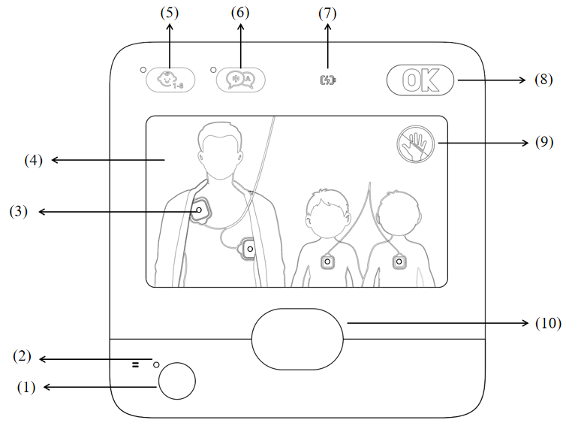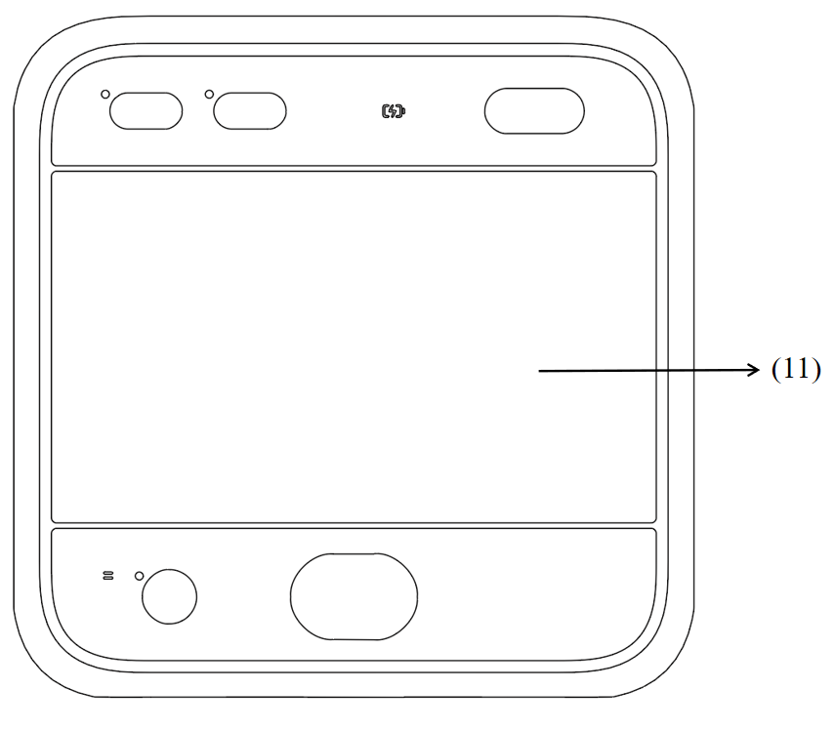
Fig. 1 Front view
(1) On/Off switch
(2) Device operation indicator
When indicator is green: device switched on as ready for operation
(3) Electrodes placing indicator
(4) Electrodes placing guidance
(5) Child button
(6) Language button
(7) Charging indicator (only for re-chargeable battery)
When battery is low, charging indicator blinks red.
When battery is charging, indicator blinks yellowish green.
When battery capacity is ready for operation or fully charged, indicator displays yellowish green without blinking.
(8) Status display (only simulates the display of normal status)
(9) No touching patient indicator
(10) Shock button
(11) LCD display
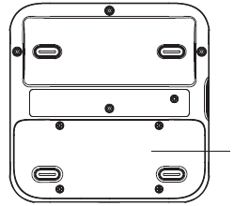
1
Fig. 2 Back View
(1) Rechargeable lithium battery
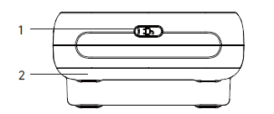
图 3 底部视图
（1）充电插座
（2）可充电锂电池
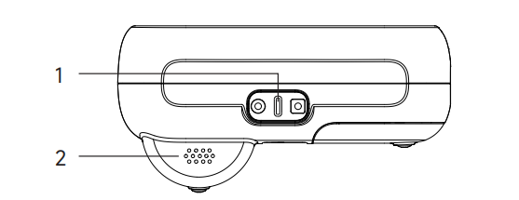
图 4 侧视图
- 电极插座
- 扬声器

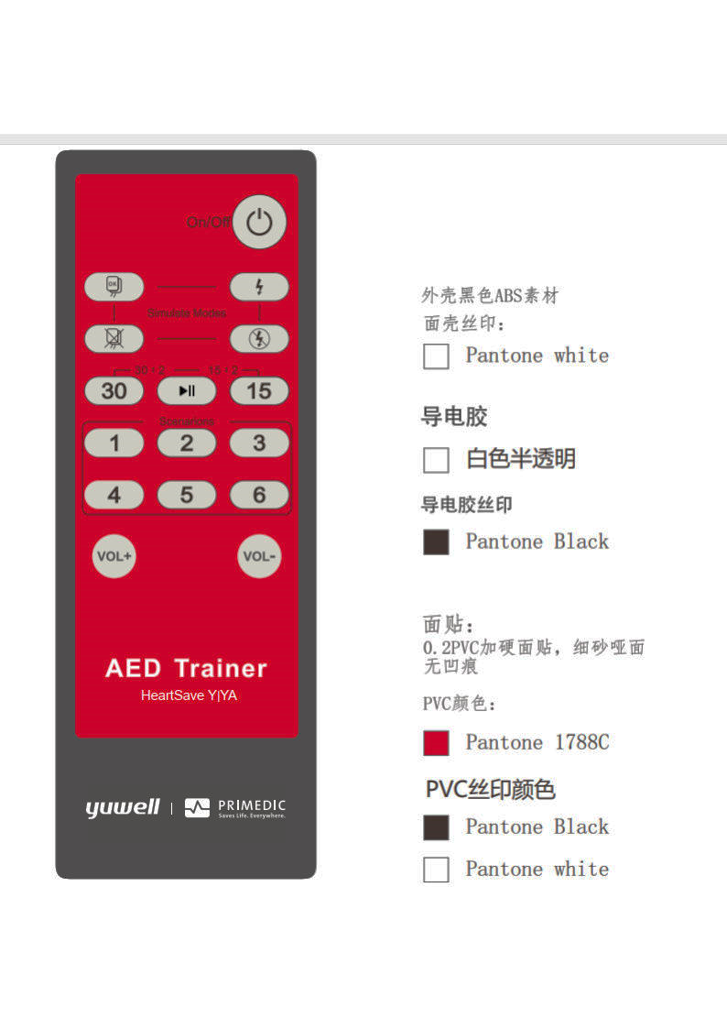
1
2
4
6
7
3
10
10
9
8
5
图 5 遥控器
- 关机按钮 – 关闭训练机
- 标准训练模式
共有6种标准训练模式。通过按遥控器上的1-6键可以选择不同的训练场景。场景1至3以全自动模式运行，场景4至6以半自动模式运行。下表显示了可使用的预设配置。
- 儿童模式的30:2心肺复苏模式切换
- 儿童模式的15:2心肺复苏模式切换
- 播放/暂停按钮
操作过程中，此按钮可用于暂停序列和语音提示。再次按下此按钮可继续训练模式。
- 模拟：电极连接到人体模型
连接标准训练电极后，按下按钮6，通知机器电极已连接并开始节律分析。
- 模拟：电极与训练模型断开连接 – 仅在电极连接时激活
- 模拟：电击建议 – 仅在电极连接时激活
- 模拟：无电击建议 – 仅在电极连接时激活
- 音量+/-键

场景编号 | 描述 | 序列
1  全自动模式 | 每次分析结果：  - 建议电击  - No shock recommended  - No shock recommended  - No shock recommended  - No shock recommended  - No shock recommended | - Defibrillation  - Two minutes CPR  - No defibrillation  - Two minutes CPR  - Rest no defibrillation
2  全自动模式 | 每次分析结果：  - 建议电击  - 建议电击  - No shock recommended  - No shock recommended  - No shock recommended  - No shock recommended | - Defibrillation  - Two minutes CPR  - Defibrillation  - Two minutes CPR  - Rest no defibrillation
3  全自动模式 | 每次分析结果：  - No shock recommended  - 建议电击  - No shock recommended  - 建议电击  - No shock recommended  - 建议电击 | - No defibrillation  - Two minutes compression-only CPR  - Defibrillation  - Two minutes compression-only CPR  - Rest repeat sequence above
4  semi-automated mode | 每次分析结果：  - 建议电击  - No shock recommended  - No shock recommended  - No shock recommended  - No shock recommended  - No shock recommended | - Defibrillation  - Two minutes CPR  - No Defibrillation  - Two minutes CPR  - Rest no defibrillation
5  semi-automated mode | 每次分析结果：  - 建议电击  - 建议电击  - No shock recommended  - No shock recommended  - No shock recommended  - No shock recommended | - Defibrillation  - Two minutes CPR  - Defibrillation  - Two minutes CPR  - Rest no defibrillation
6  semi-automated mode | 每次分析结果：  - No shock recommended  - 建议电击  - No shock recommended  - 建议电击  - No shock recommended  - 建议电击 | - No defibrillation  - Two minutes compression-only CPR  - Defibrillation  - Two minutes compression-only CPR  - Rest repeat sequence above

Language button
You can press the language button during operation until target language selected.The HeartSave myPAD trainer optionally supports up to 6 languages.When language button pressed, the selected language is also acoustic prompted.

Child button
By pressin the child button, the HeartSave myPAD trainer switches to child mode.The default CPR compression are changed to 15 for each cycle.Optionally, this CPR instructions could be also changed to 30 chest compressions with button 3 on the remote control.

Preparation before starting device

Unpack
When you receive the package, check the packaging and device.In case of any visible damage, please contact the manufacturer or your distributor immediately.Provide serial number of the device and a description of the damage.

Prepare battery
The device uses a rechargeable lithium-ion battery.If your battery is not installed, please install the battery into battery slot of the device.

Battery installation
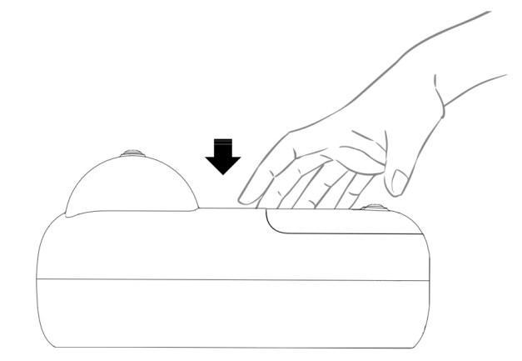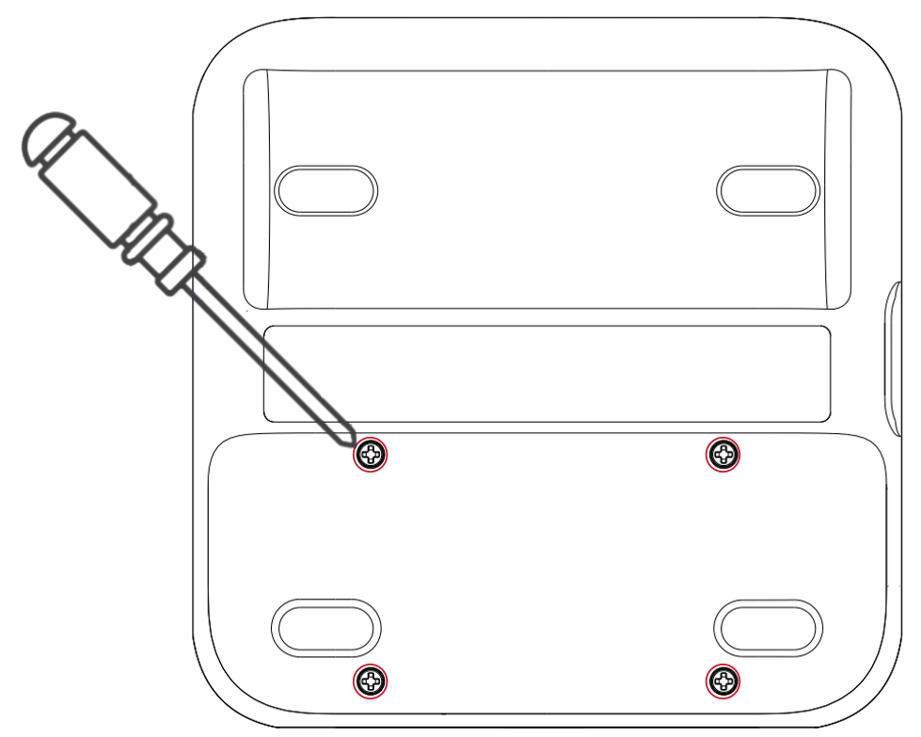
Fig. 6 Insert the battery
Steps:Put the device top down on a soft flat surface.
- Put the device top down on a soft flat surface.
- Place the battery in the direction of the arrow into the device until it reaches its end position as shown in Fig. 6.
- Tight 4 screws with provided screwdriver until fully fixed.

Battery removal
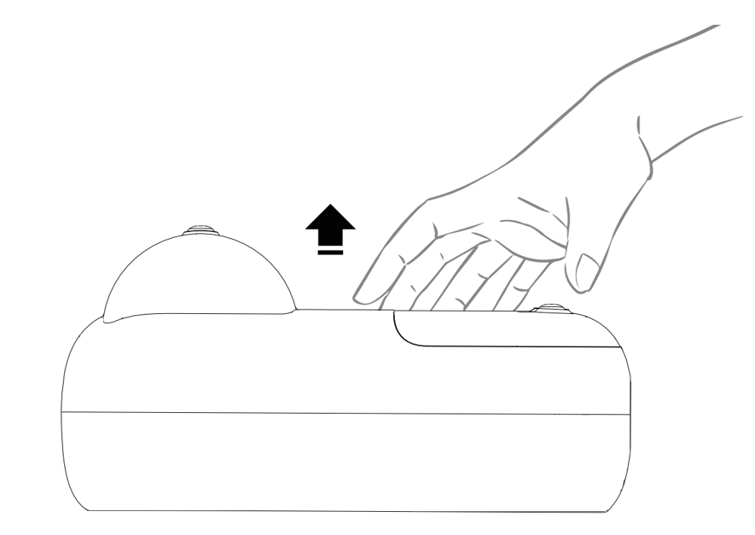
Fig. 7 Remove the battery
To replace a new battery, you need to remove the battery from device with following steps.
Steps:
- Put the device top down on a flat surface.
- Use provided screwdriver to remove 4 screws from the battery.
- Pull the battery with the direction of the arrow out of the slot slightly.

Using HeartSave myPAD trainer

Switch on the trainer
The trainer can be switched on via pressing the power button of device.

连接电极线缆与电极片
训练器配有训练电极，其中包括线缆和电极片。
按照图 8 连接电极线缆与训练电极片。
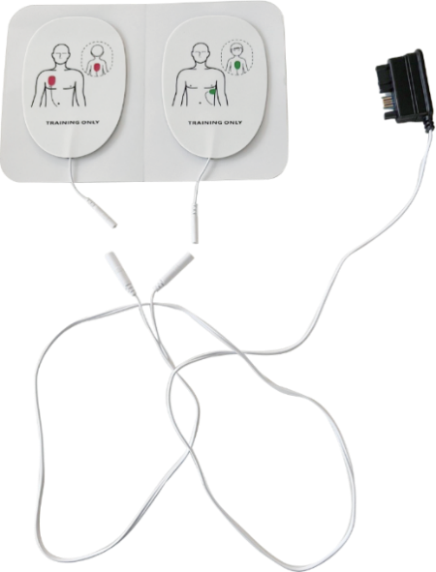
1
2
图 8 连接电极线缆与电极片
- 电极片连接器
- 线缆连接器

插入电极
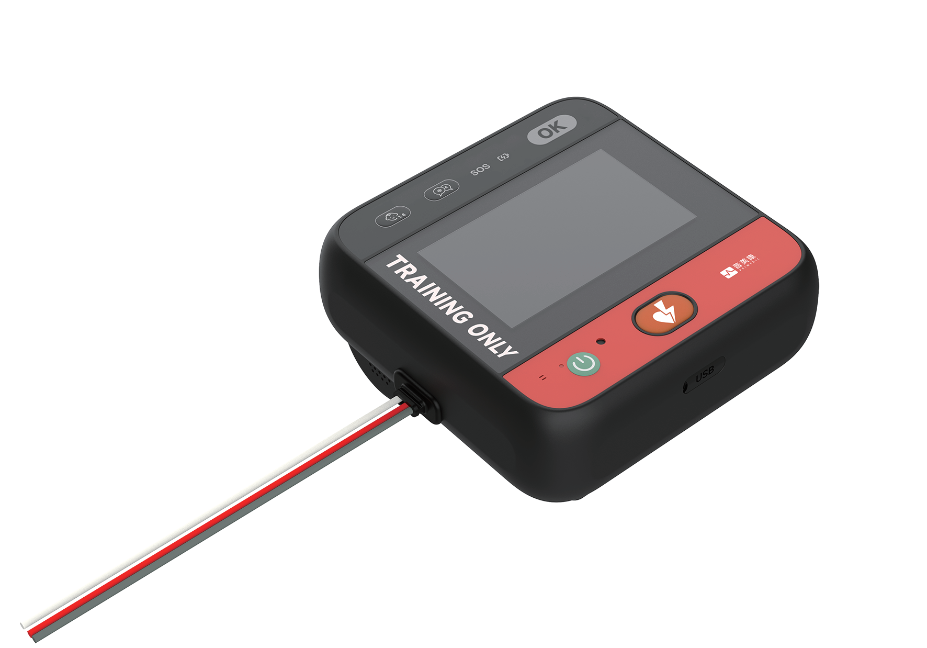
图 9 插入电极
Steps:After hearing the prompt "Insert electrodes" insert the electrodes plug into the socket as shown above.
- 听到“插入电极”提示后，将电极插头插入插座，如上所示。

贴上 辅助电极片（可选）
图 10 将辅助电极片贴到成人模型上

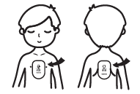
图 11 将辅助电极片贴到儿童模型上
将辅助电极片贴到人体模型上时，位置应如图 10 和图 11 所示。

贴上辅助电极片的步骤
Steps:
- 打开辅助电极片袋。
- 从辅助电极片上取下保护箔，并将辅助电极片贴到指定位置。
- 小心按压电极，确保与人体模型良好接触。
- 辅助电极片也可以留在人体模型表面，以避免每次训练后都要移除。

辅助电极片的功能
- 接触检测：在训练期间自动检测训练电极片是否已连接。
- 位置引导：提供训练电极片放置的视觉说明。

贴上电极

图 12 将电极贴到成人模型上

图 13 将电极贴到儿童模型上

HeartSave myPAD 训练器将发出语音提示，引导您将电极贴到人体模型上。
< 如图所示贴上电极 >
< 移除患者胸部所有衣物，打开电极包装，并如图所示将其贴到患者裸露的胸部 >
Steps:
- 打开袋子取出训练电极。
- 对于没有辅助电极的型号，请将训练电极贴到人体模型上训练电极图示的相应位置。对于有辅助电极的型号，请先将辅助电极贴到图示中训练电极的指定位置，然后再将训练电极贴到辅助电极上。
注意 | - 训练电极片儿童和成人通用，如上图所示。  - 训练电极片外观与真实的除颤器相似，但不会产生高压电击。请注意，训练电极片仅用于训练目的，不得连接到除颤器以用于紧急情况。  - 请勿弯曲或拉伸电极线缆或电极片。  - 对于辅助电极片，请先将辅助电极片贴到人体模型上，然后将训练电极片贴到辅助电极片上。

分析心律

开始分析
在电极已连接的情况下，有两种选项可以开始分析：
- Connect electrode connector to the trainer.The analysis starts when training electrodes attached with auxiliary electrodes.
- Press button 6 (Fig. 5) on the remote control to start the analysis.
- Place electrodes onto auxiliary pads (optional).
When analysis starts you will hear the voice prompts:
< Analysing rhythm >< Don’t touch the patient >
< Don’t touch the patient >Interrupt the analysis

Interrupt the analysis
In case of analysis starts, there are several options to interrupt the analysis:
- Interrupt the analysis by disconnect one pad
- Press button 7 (Fig. 5) on the remote control
- Remove the electrodes connector from device socket.

Simulate defibrillation
The result of the analysis refers to the selected scenario on the remote control.

Shock advised – Simulation:建议电击
When press button 8 (Fig.5 Remote Control), the current scenario is interrupted and simulate a shock recommendation immediately not depending on the before chosen scenario.There will be an analysis right after pressing the button and the trainer will always recommend a shock for the next sequences.
注意 | Only available when trainer electrodes are connected.

No shock advised – Simulation:No shock recommendation
When press button 9 (Fig.5 Remote Control), the current scenario is interrupted and simulate a no shock recommendation immediately not depending on the before chosen scenario.There will be an analysis right after the pressing the button and the trainer will always recommend no shock for the next sequences.
注意 | Only available when trainer electrodes are connected.

CPR – Cardiopulmonary Resuscitation
注意 | For auxiliary electrode pads:If the electrode plug is disconnected during CPR, the CPR process will be interrupted, and the device will prompt < Stop chest compression>. If CPR is initiated due to unattached electrode pads and the pads are subsequently attached, the CPR process will also be interrupted, and the device will prompt < Stop chest compression>.

CPR with respiration
This chapter is applied for scenario 1, 2, 4 and 5 on remote control.
The duration of the CPR is approx. 120s consists of chest compressions and rescue breaths.Adult and child should follow different compression recommendations as below.

Adult mode30:2 Adult CPR Mode, following the standard CPR procedure.
30:2 Adult CPR Mode, following the standard CPR procedure.
Device prompts:
< Begin CPR >< Give 30 chest compressions >
< Give 30 chest compressions >< Give two rescue breaths >
< Give two rescue breaths > The above steps are repeated 5 times, then proceed to section 4.6.1.
The above steps are repeated 5 times, then proceed to section 4.6.1.

Child mode15:2 Paediatric CPR Mode, also possible to switch to 30 compressions.
15:2 Paediatric CPR Mode, also possible to switch to 30 compressions.
Device prompts:
< Begin CPR >< Give 15 chest compressions >
< Give 15 chest compressions >< Two rescue breaths>
< Two rescue breaths>The above steps are repeated 7 times, then proceed to section 4.6.1
重复上述步骤7次，然后进入第4.6.1节。

无呼吸人工心肺复苏
本章节适用于遥控情景3和情景6。
心肺复苏持续时间约为120秒，包括胸部按压。

Adult mode30:2 Adult CPR Mode, following the standard CPR procedure.
30:2 Adult CPR Mode, following the standard CPR procedure.
Device prompts:
< Begin CPR >< Give 2-minute chest compressions >
< 进行2分钟胸部按压 >
< 停止检查按压 >
The above steps are repeated 5 times, then proceed to section 4.6.1.

Child mode15:2 Paediatric CPR Mode, also possible to switch to 30 compressions.
15:2 Paediatric CPR Mode, also possible to switch to 30 compressions.
Device prompts:
< Begin CPR >< Give 2-minute chest compressions >
< 进行2分钟胸部按压 >
< 停止检查按压 >
重复上述步骤7次，然后进入第4.6.1节。

心肺复苏反馈传感器（可选）
当使用心肺复苏反馈传感器时，在心肺复苏过程中，按压频率和深度将通过声音或视觉提示。将有无按压、按压不佳或按压良好等提示。按压质量是根据每个周期1-15次按压的平均测量值计算的。

根据ERC指南，每分钟按压频率在100到120次之间被认为是可接受的，按压深度应在50毫米到60毫米之间。

设备连接心肺复苏传感器时语音提示
< 按快一点 > 如果平均按压频率过慢，设备将提示
< 按慢一点 > 如果平均按压频率过快，设备将提示
< 按重一点 > 如果平均按压深度过浅，设备将提示
< 按轻一点 > 如果平均按压深度过深，设备将提示
< 使用心肺复苏传感器提高心肺复苏质量 > 如果未使用心肺复苏传感器，设备将提示
< 按压质量好，请保持 > 如果所有按压质量都良好，设备将提示
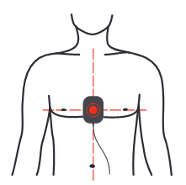
图 14 心肺复苏反馈传感器的位置

关闭训练器
可以通过以下方式关闭训练器：
- 按设备电源按钮
- 按遥控器上的“开/关”按钮

产品维修和保养

设备维护
- 请用蘸水或中性洗涤剂的软布清洁主机。
- 请勿使用汽油清洁训练器。
- 请勿让水等液体流入设备。
- 请勿将训练器存放在阳光直射、高温、潮湿、多尘和腐蚀性气体的地方。请参阅第7章。

电极片维护
- 电极片应保持清洁，避免灰尘、油污和脏污。
- 请勿刮擦粘合表面。
- 请勿用水或其他液体清洁电极。
- 请勿将电极存放在阳光直射、高温、潮湿、多尘和腐蚀性气体的地方。
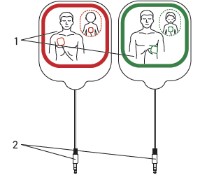
图 15 训练电极片
(1) 带有保护膜的训练电极片，用于模拟期间重复使用。
(2) 电极插头

电池维护
- 请勿超过规定电流充电/放电。
- Do not short circuit the battery pins, it may cause permanent damage.
- Do not burn or destroy the battery.
- Store batteries in a cool and dry place.
- Keep away from children.
注意 | Rechargeable battery maintenance instruction  Periodic charging and discharging - If the battery is planned to store for a long period (> 6 months), it is recommended to fully discharge the battery and recharge it once every half year.
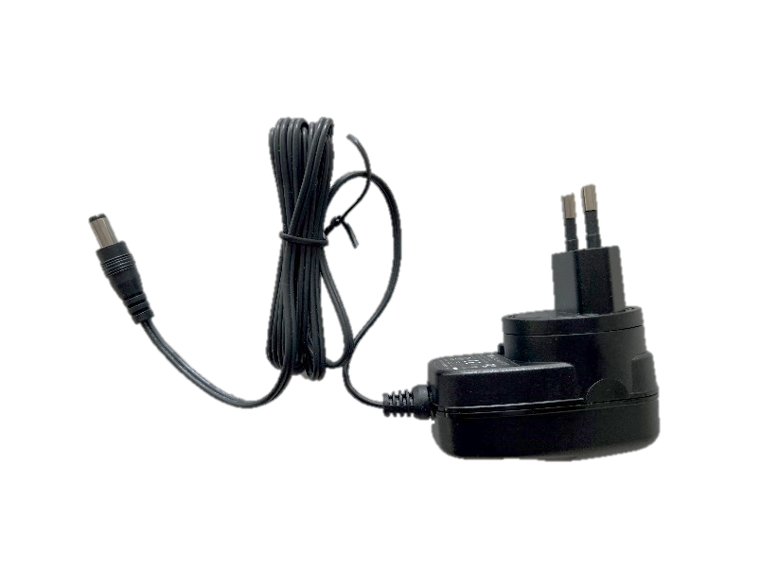
2
1
Fig. 16 Power-Adapter
(1) Power socket plug
(2)Charging cable plug

Programming the trainer
To trainer provides a possibility to update the software or configuration.To update the software or configuration, you need to prepare:
- 1 x USB drive
- 1 x Type-C to USB adapter

USB drive must follow specifications below:
- Capacity no greater than 32GB
- Format:FAT32
- USB 2.0 / USB 2.0 card reader

Procedure for USB drive updates:
- Insert the USB drive into the Type-C to USB adapter port, then connect the Type-C end of the adapter cable to the corresponding port on the AED trainer.
- Connect the power adapter securely to the trainer’s charging port
- Power on the AED trainer.
- Once the display is activated, press and hold the language button until the program update interface appears / language button flashes.
- Wait for the update process to complete.
注意 | During the update process, the language button flashes.  When programming completedLanguage button light remains on, or the device restarts automatically.  Language button light remains on, or the device restarts automatically.  When programming failedLanguage button light switches off.  Language button light switches off.

Disposal
At the end of the service life of the device, please hand it over to a local recycling company.Proper disposal of this device is conductive to environmental protection.

Technical specification
DEVICE Power supply
Power supply | 7.2V 2950mAh  (rechargeable lithium battery)
Residual current when switched off | ≤10μA (max)
Rated current during operation | ≤ 500mA
Power Adapter | Input:AC 100–240V, 50/60Hz, 0.5A Max.  Output:DC 15V 0.8A
Main device | DC12 V, ≤1 A
Dimensions (L x W x H) | 151 ± 2mm x 151 ± 2mm x 73cm ± 2cm
Weight | 1.0kg ± 0.2kg
Power adapter of battery | Input:AC 100-240V, 50/60Hz  Output DC 15V 0.8A
DISPLAYType
Type | color LCD
Dimensions | 4.3 inch
Resolution | 480 × 272 pixels
REMOTE CONTROLPower supply
Power supply | DC 3.0V (AAA battery x 2)
Residual current when switched off | 5uA (max)
Rated current during operation | 15mA (max)
ENVIRONMENT SPECIFICATIONOperating conditions
Operating conditions
Temperature | -10°C – 55°C
Relative humidity | ≤ 95% RH
Air pressure | 86kPa – 106kPa
Altitude | < 2000m from sea level
STORAGE CONDITIONSTemperature
Temperature | -20°C – 60°C
Relative humidity | ≤ 95%RH
Air pressure | 70kPa – 106kPa

保修
普美德（江苏）医疗科技有限公司承诺自购买之日起对本设备提供2年保修期。请妥善保管购买凭证。
在此期间，本公司将免费排除本设备因材料或生产原因造成的缺陷和故障。本公司可选择维修或更换来提供维护服务。
履行保修责任不延长原始保修期。保修和法定担保要求不适用于以下情况：可用性未受到重大影响，自然磨损（例如电极片耗材），或因错误或错误操作、过度使用和手册中规定以外的特殊外部力影响造成的损坏，以及购买者或第三方未按规定修改或维修设备。
排除对本公司的其他合同或非合同要求，除非这些要求是基于故意行为、过失行为或强制性法律责任原则。
如需保修，请将设备、购买凭证（如发票副本）和保修卡寄送给您的销售商或本公司。
保修期后，本公司将继续为您提供售后服务，但会相应收取一定费用。

附录 A：索引图
Fig. 1 Front view6
Fig. 2 Back View6
Fig. 3 Bottom View7
Fig. 4 Side View7
Fig. 5 Remote Control7
Fig. 6 Insert the battery10
Fig. 7 Remove the battery10
Fig. 8 Connect cables with pads11
Fig. 9 Inserting electrodes11
Fig. 10 Application of auxiliary pads to an adult manikin12
Fig. 11 Application of auxiliary pads to a child manikin12
Fig. 11 Application of electrodes to an adult manikin12
Fig. 12 Application of electrodes to a child manikin13
Fig. 14 Position for CPR Feedback Sensor15
Fig. 15 Training Electrode Pads16
Fig. 16 Power-Adapter17

附录 B：象形图
 | 一般警告标志
 | 请参阅说明手册/小册子。
 | 请勿将产品作为生活垃圾处理
 | 可回收
 | 序列号
 | 制造商
 | 生产日期
 | 易碎物品
 | 此面朝上
 | 保持干燥
 | 运输时请勿旋转

